**Database Management System | ER Model**

ER model stands for Entity Relationship model. It is a graphical representation of the conceptual design of the actual database.

ER Model is used to model the logical view of the system from data perspective. It consists of the following components:

**Entity:**

Entity is a real world object which has independent existence and about which we need to collect data. It is distinguishable from other objects. Entity in the database contains the data about the real world object. For example, in a banking environment, entities are CUSTOMERS, BANK SUPPLIERS etc.

Entities are represented by rectangle.

**Entity**

**Entity Set:**

An **entity set** is a set of entities of the same type that share the same properties.

Example: set of persons, companies, trees, loans customer.

Entities are characterized into two types:

**Strong Entity:**

These entities are having a primary key attribute which uniquely identifies the other entity.

**Student**

**Weak Entity:**

These entities don’t have the key attribute and depends upon the other entitiesthrough foreign key.

Project allotted

**Student**

**Attribute:**

Entity has set of properties. These properties of each entity called as attributes.

For example, a car entity would be described by attributes such as model, price, color, registration number etc…

Attributes are represented as shown below

The following diagram describes the “CAR” entity with attributes. The underlined attribute represent primary key of the entity.

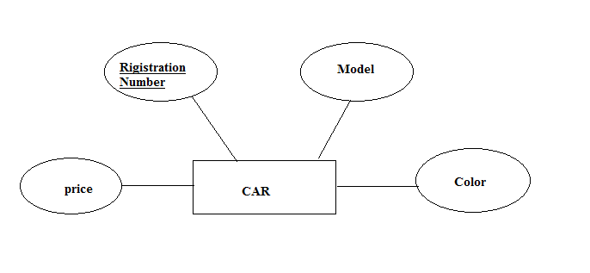

An attribute can be characterized into following types,

* Simple attribute
* Composite attribute
* Single Value attribute
* Multi valued attribute
* Derived attribute

**Simple attribute:**

An attribute is classified as a simple attribute if it cannot be partitioned into smaller components. For example, age and sex of a person. Simple attribute is represented by an oval symbol.

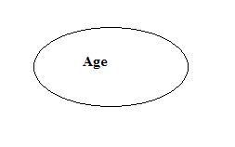

**Composite attribute:**

These composite attribute can be sub divided into smaller components which further forms an attribute. For example attribute “Name” can divided into “First Name” and “Last Name”.

Here “Name” is the composite attribute.

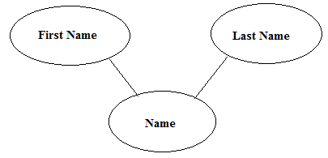

**Multi Valued Attribute:**

An attribute which can hold more than one value, it is then termed as multi-valued attribute. For example, phone number of a person. Multi valued attribute is represented by double oval.

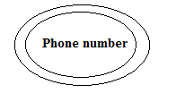

**Derived attribute:**

Derived attributes calculates its value from another attributes. For example the attribute age calculates its value from the attribute date of birth. Derived attributes is represented by dashed oval.

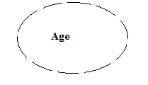

**Relationship:**

A relationship is defined as association between two or more entities. Normally, a verb in a sentence signifies a relationship. For example, employee **works** in a department. Relationship is represented by diamond symbol.

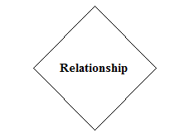

**Degree of a relationship:**

It specifies the number of entities involved in a relationship. Degree of relationship can be classified into following types:

**Unary Relationship:**

If only one entity involves in a relationship then it is called unary relationship. For example employee (Manager) supervises another employee.

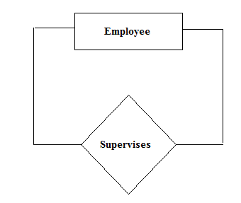

**Binary Relationship:**

When two entities involved in a relationship then it is called binary relationship. For example teacher teaches a student.

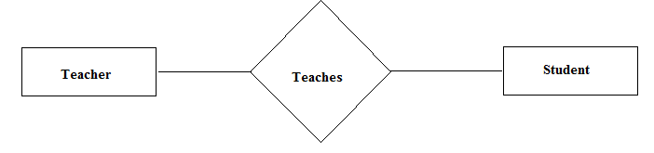

**N-ary Relationship:**

When there are ‘n’ numbers of entities involved in a relationship then it is called N-ary relationship.

**Connectivity of a relationship:**

Connectivity of a relationship describes how many instances of one entity type are linked to how many instances of another entity type. Various categories of connectivity of a relationship are;

**One-To-One:**

In this one instance of entity is relation with only one instance of another entity. For example, “Student allotted project” signifies One-To-One Relationship.

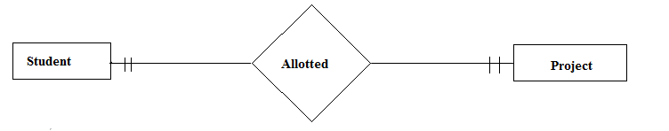

**One-To-Many:**

In this one instance of entity is relation with many instances of another entity.  “A department recruits faculty” is a one-to-many relationship because a department can recruit more than one faculty, but a faculty member is related to only one department.

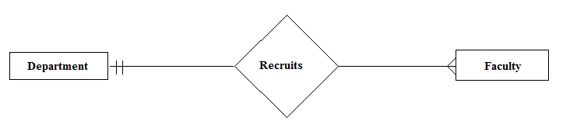

**Many-To-One:**

In this many instances of one entity are relation with one instance of other entities.  “Many cars are owned by a person” is a many-to-one relationship because a person can own many cars but a particular car is owned only by one person.

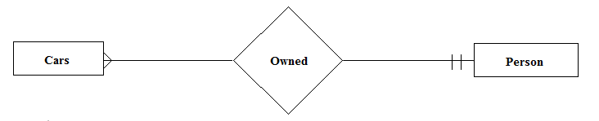

**Many-To-Many:**

 “Author writes books” is a many-to-many relationship because an author can write many books and a book can be written by many authors.

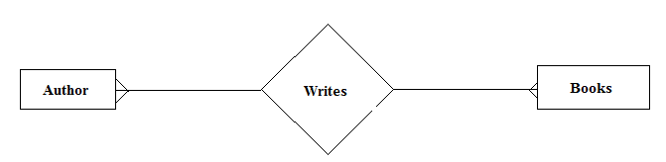

The complete ER diagram of the entity type STUDENT with its attributes can be represented as follows:

